[Jeban Ignesh Jebamalai](mailto:jeban.jebamalai@relevantz.com)**-11963**

**Problem Solving:**

**Online Bus Reservation System.**

**W3H:**

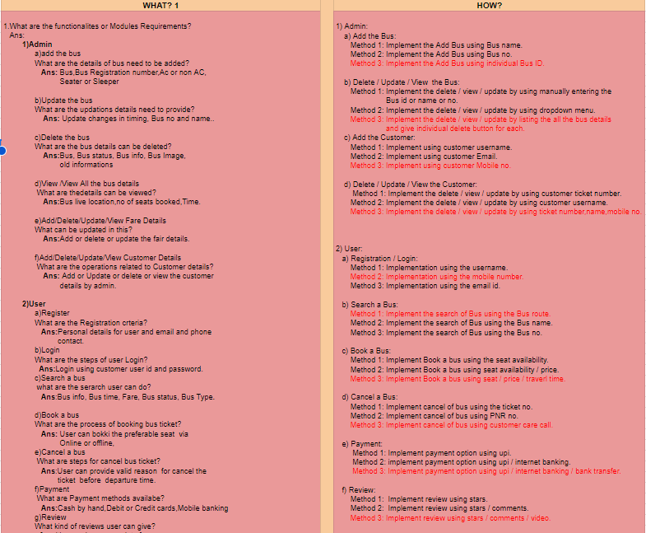



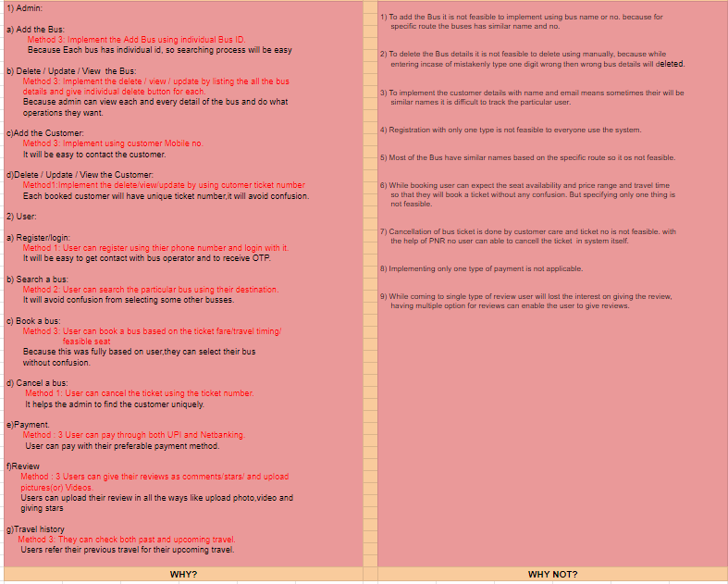

**Algorithm:**

**For Admin**

Step 1:Start.

Step 2:Open Application.

Step 3:Admin adds the bus using an individual bus ID.

Step 4:In Add bus ,admin can add the bus reg-no,Bus type(ac-nonAc),Operator name.

Step 5:Admin can view the bus details by clicking the view button.

Step 6:Admin can update the details of the particular bus by entering its individual ID.

Step 7:Admin can delete the bus by clicking the delete button.

Step 8:Admin can add the ticket fare for the bus by using the individual Id

Step 9:Admin can Update/delete the ticket fare based on the route that bus is running.

Step 10:Admin can view the booked customers details by using the ticket number.

Step 11: Admin can approve the ticket cancellation if it's valid(before the specified time).

Step 12: Admin can send the details of the booked customers to the driver of the bus.

Step 13: Admin can send the details like bus reg no,driver name,live tracking to the booked customer’s phone number.

Step 14: Stop.

**For User**

Step 1:Start.

Step 2:Open application.

Step 3:By clicking Sign up,create an account,else login to enter the application.

Step 4:Users can search the bus using their traveling destination in the search button.

Step 5:Click on the preferable bus,check ticket availability, (ac or non Ac),seat allocation,amount

And pickup and drop timing.

Step 6:If all things are satisfied, book the bus,else go to step 4.

Step 7:Select the payment method to pay the bus ticket.

Step 8:If the payment method is not fair to the user, go to step 7.

Step 9:if the payment method is successful,go to the next step 10.

Step 10:Now,users download the ticket.

Step 11:If needed, the user can cancel the ticket before specified time.

Step 12:On the journey users can check bus and driver details.

Step 13:If users are satisfied,they can review the bus services.

Step 14:Stop.

**Flow Chart:**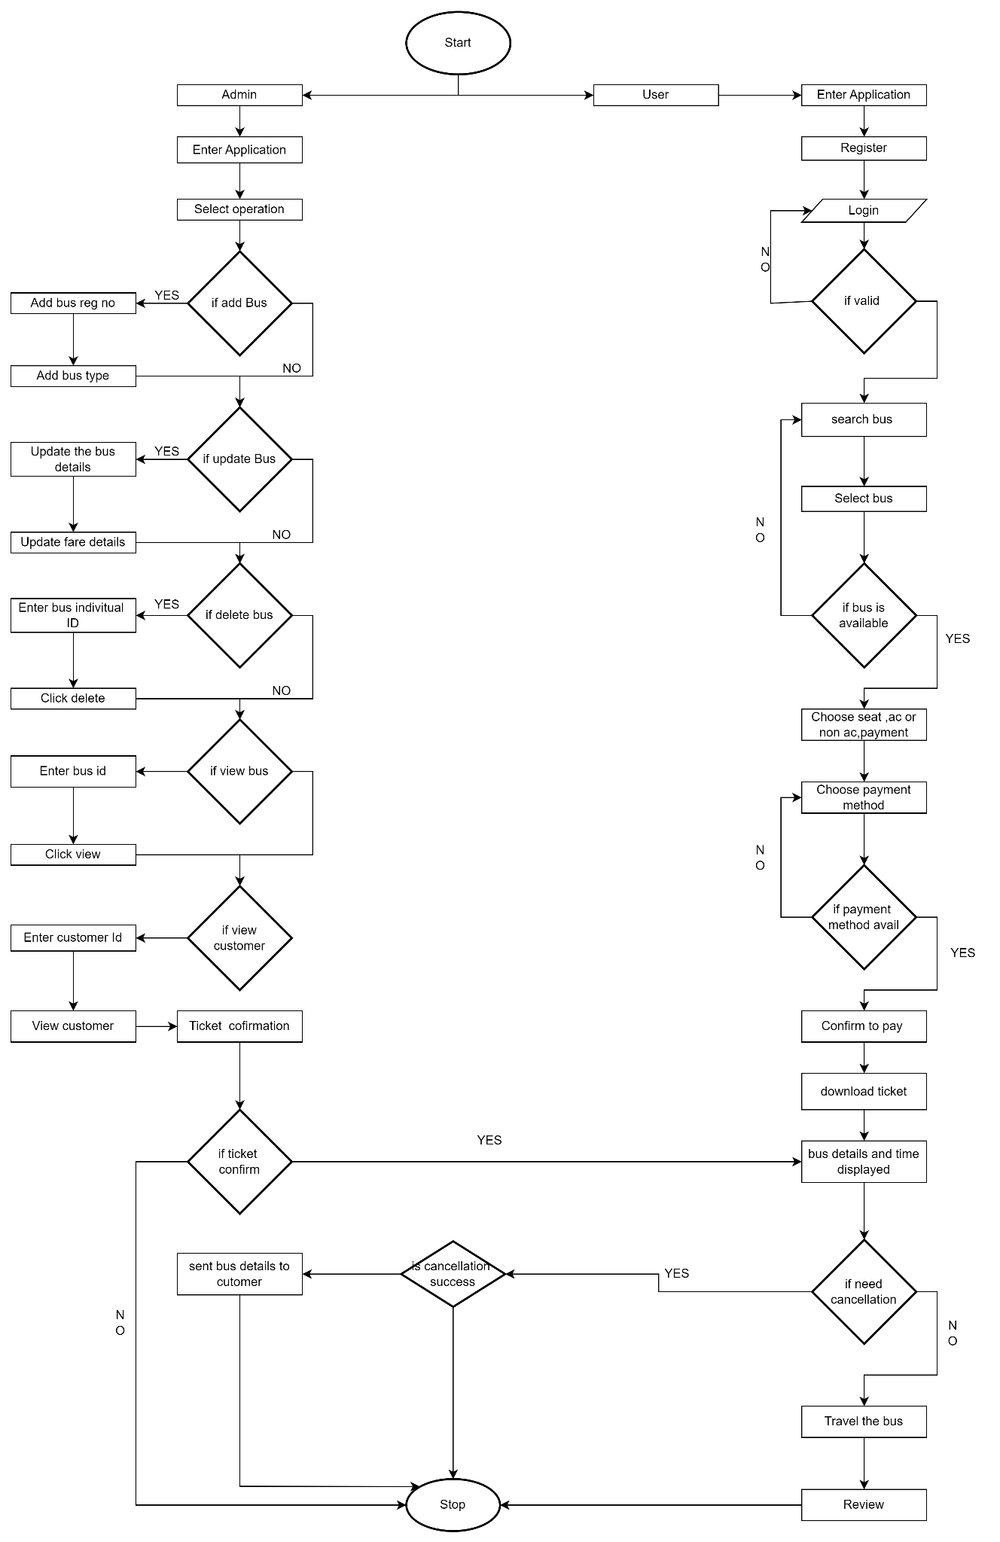

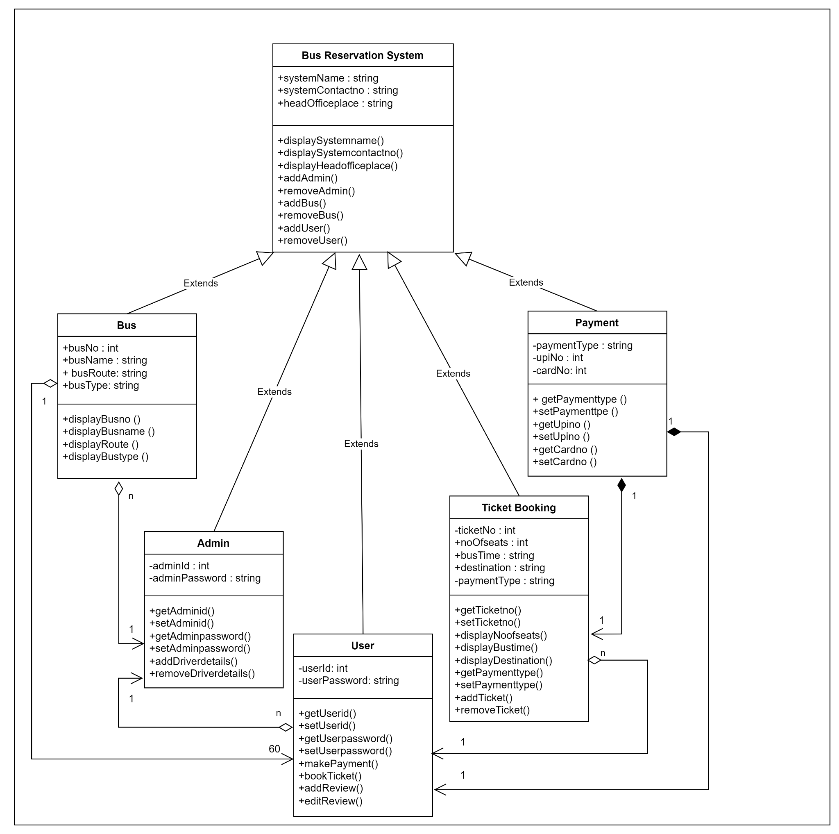

**UML:**

**Class Diagram:**

**Use Case:**

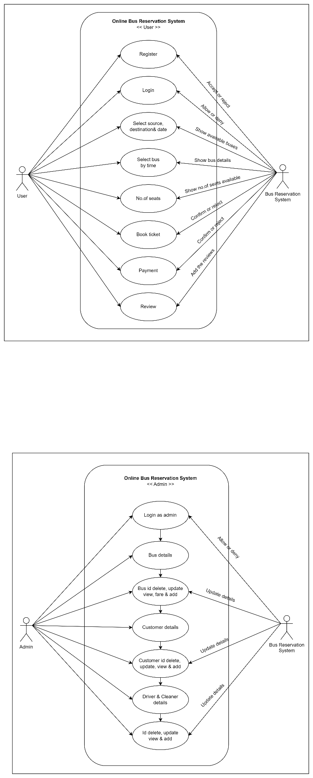

**Sequence Diagram:**

